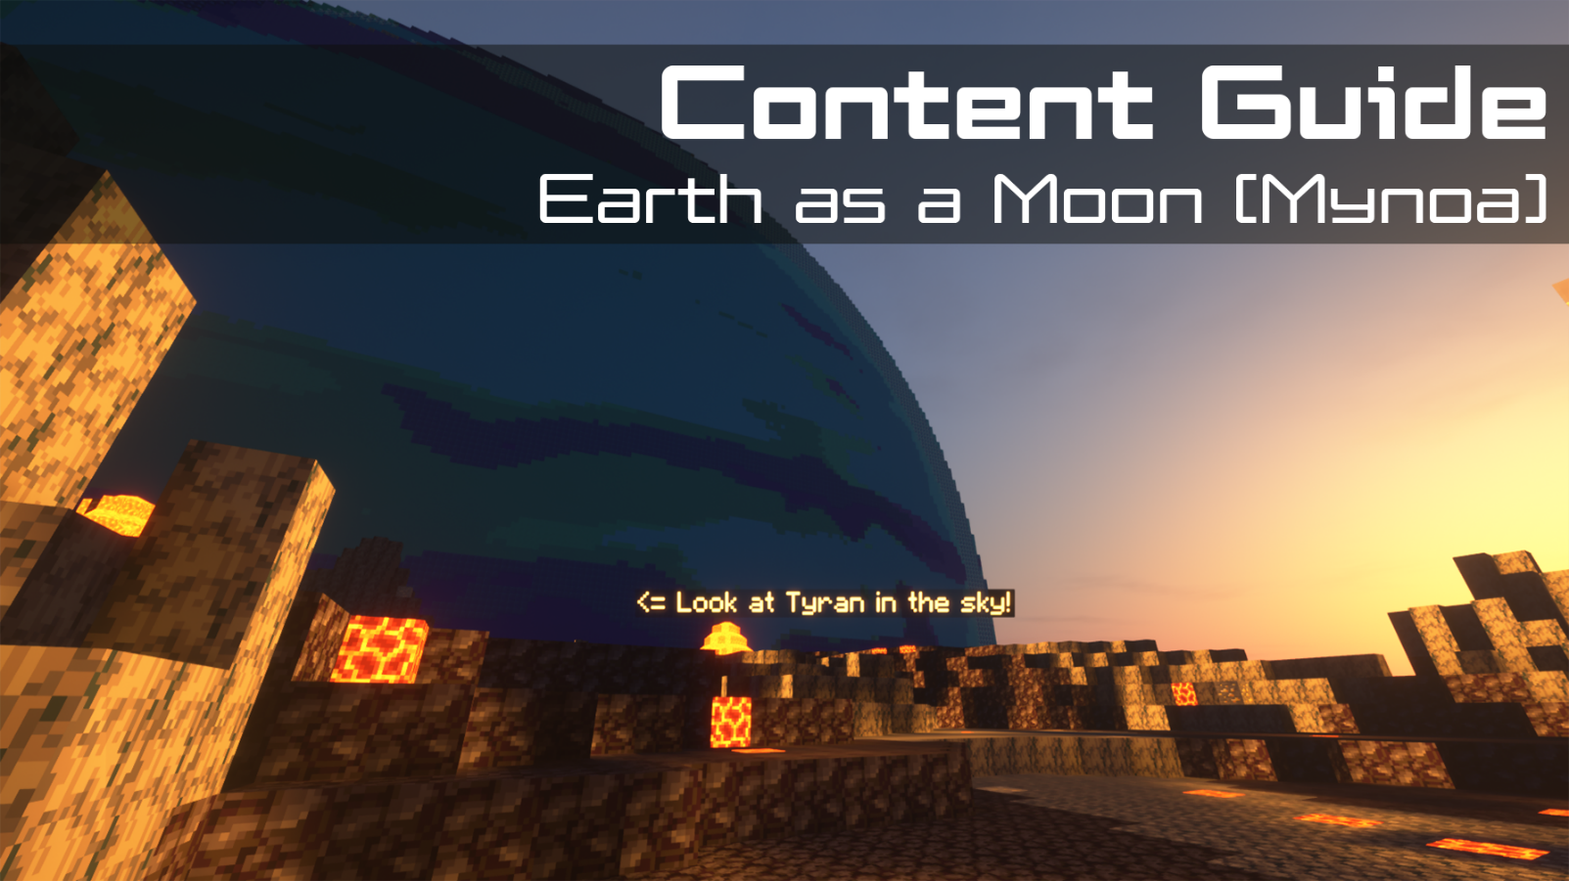
Contents  📖 Narrative Focus 2  🎯 Objectives 2  🏫 Standards Alignment 2  📝 Assessments 2  💡 Tips for Instruction 3  🔭 Observable Concepts 3  ❓ Expected Questions 4  🔬 Connected Classroom Activities 4  ☑️ World Quest Progression 4  🗺️ Maps 5  👩🏽‍🔬 NPC's and Their Roles 8 | How to Use This Guide  This content guide is intended for parents, librarians, teachers, and other educators who are interested in facilitating learning experiences with the WHIMC server, in home or classroom-based settings. It reviews all the critical components of a given WHIMC world as well as what might be learned in it.  This world is intended to be encountered after the initial tutorial and “What-If” worlds, for a full overview of world order, see the teacher guide home page.  More information about project WHIMC can be found on our website at whimc.org. Teachers and participants unfamiliar with computer-based Minecraft: Java Edition can learn how to install and control the game here as well.

📖 Narrative Focus
Mynoa is another What-if world with three sides representing different geographic locations around the planet. It’s different in that it’s a mystery to students! We don’t tell them it’s earth as a moon, we let them collect evidence and compare and discuss with one another to test and figure it out. They’ll also learn about magnetic fields for the first time, and see how they relate to auroras.

🎯 World Overview
This world flips the Earth–Moon relationship: Earth-like "Mynoa" is the moon, orbiting a much larger planet called "Tyran." It's the most unusual "what-if Earth" in the set.
Tyran Fixed in the Sky, Magnetic Fields
- Like our Moon, Mynoa is tidally locked to its parent — so Tyran hangs at a fixed position in the sky, never rising or setting. They are not tidally-locked to the local star, Zon, however.
- Tyran is so large and close that it appears bigger in the sky than the Sun.
- Your view of Tyran depends entirely on your longitude and latitude; from the far side of Mynoa, you'd never see Tyran at all.
- Our Tyran is modeled after Neptune, which has massive magnetic fields, reducing the radiation from solar winds dramatically.
The Daily Eclipse
- As Mynoa orbits Tyran, the Sun and stars move across the sky, but Tyran stays put.
- Because Tyran looms so large, it eclipses the Sun for several hours each "day," around local noon. This can be seen in the first world with the sun blocked out with the gas giant above.
- During this daily eclipse, temperature and winds drop noticeably — a built-in midday cool-down found nowhere on Earth.
No Seasons, Significant Tides, Tectonic Impact
- Mynoa's rotation axis is essentially un-tilted, so the world has no seasons.
- Tyran has more mass and gravitational pull than the moon in our scenario, making for a larger pull on tides that can be seen in the Mangrove side, where there’s evidence of a wide range.
- The larger tidal pull causes volcanic activity on the ridges of the planet as it’s pulled apart by the forces of the massive gas giant.

🎯 Objectives
- Students will infer effects of Tyran on Mynoa through observations and measurements.
- They’ll have to distinguish between signals and noise to connect evidence to make hypotheses.
- In doing this they engage in collaborative argumentation!

🏫 Standards Alignment
Next Generation Science Standards (reference)
- K-ESS2.D: Weather and Climate
- 1-ESS1.A: The Universe and its Stars
- 1-ESS1.B: Earth and the Solar System
- 2-ESS1.C: The History of Planet Earth
- 5-PS2-1: Support an argument that the gravitational force exerted by Earth on objects is directed down
- 5-PS2.B: Types of Interactions
- 5-ESS1.A: The Universe and its Stars
- 5-ESS1.B: Earth and the Solar System
- MS-ESS1-1: Develop and use a model of Earth-sun-moon system to describe the cyclic patterns of lunar phases, eclipses of the sun and moon, and seasons.
- MS-ESS1-2: Develop and use a model to describe the role of gravity in the motions within galaxies and the solar system.
- MS-ESS1-3: Analyze and interpret data to determine scale properties of objects in the solar system.
- MS-ESS1.A: The Universe and its Stars
- MS-ESS1.B: Earth and the Solar System
- MS-ESS1.C: The History of Planet Earth
- MS-ESS2.A: Earth’s Materials and Systems
- MS-ESS2.D: Weather and Climate

📝 Assessments
During WHIMC camps, instructors provide opportunities for students to express what they have learned in the form of short answer questions. While teacher content guides are designed for those outside of WHIMC researcher-run camps, these prompts can be used to facilitate discussions about the server and what was learned during a playthrough of a particular world.
Self-Explanations:
Mynoa Questions | Why are the sides of Mynoa so different? | How is Mynoa different from the other What-If Earths? | Could humans survive on Mynoa? Why?
Possible Answers | They can pick any number of answers related to the influence of Tyran, like eclipse or tidal bulge or how life could develop differently | Many ways, they're probably point out Tryan | In our scenario potentially, prompts kids to think about what humans need to survive

Mynoa has three side quests available - Solis defuit, Wanna knowa mynoa? Mynoa museum mania! - in addition to the main That’s no Moon quest line that can be used to determine depth of engagement with each portion of the world by learners.
On every world there are main concepts and science variables that can be observed. Instructors can expect a minimum of 4 observations of substantive quality and 10 different science measures to consider a learner to be at a level of satisfactory engagement on Mynoa.

💡 Tips for Instruction
- To explore Mynoa, students must first finish all the other “What-If” worlds, then speak to the NPC standing outside of the Mynoa entrance on the space station hub.
- Explain to learners that each part of Mynoa is all the same planet, just different sides of it.
- The museum gives some really strong clues as to what the answer is!

🔭 Observable Concepts and Points of Interest
To see a list of all available science tools, simply type /sciencetools measure into the in-game chat, press space, and then use the arrow keys to scroll through the list of available options.
Globally
/magnetic_field - strong, influenced by nearby gas giant
/tides – much greater than earth, flooded ocean area
/radius, /atmosphere, /year, /pressure – generally similar to earth
/rotational_period, /tilt – impacted because of tidal-locking with gas giant
/radiation – much lower because of magnetic field protection from the nearby gas giant
/tectonic – the whole planet has greater effects but it’s not always noticeable
MynoaClose
Giant gas giant body in the sky
Auroras!
/temperature - 4.0C/39.2F/277.2K, lower because eclipse blocks the sun
/pressure - goes up 20% between the air and the water; in the ocean goes up the deeper you go
/wind – slowest during eclipse
/altitude – higher relative to sea level
/gravity – slightly lower due to counter-acting pull from sun and nearby gas giant
/wind – higher due to rapid temperature change by the volcanic ridge ring
MynoaHalf
Volcanoes and ash in the air
Giant Neptune-like planet on the horizon
/temperature - 52C/125F/325K, higher because volcanoes
/humidity - 3.8%, impacted by volcanoes
/atmosphere – ash in the air from volcanoes
/tectonic – volcanoes are an indicator of shifting plates
MynoaMangrove - temperature, pressure, humidity
Auroras!
The structure of the settlement, like the high walls and tower, floating loading dock
Exhibits in the museum (region: poi_mynoamuseumentrance)
/temperature - 22C/71F/295K
/humidity - 61.5%
/gravity – slightly higher due to additional pull from nearby gas giant
/magnetic_field – aurora’s are notably visible here
/tides – habitat architecture and underwater trees indicate massive variance

❓ Expected Questions
Questions Kids Might Ask | Questions Facilitators Might Ask
What do you mean that Earth is a moon?  Are there any Earth-sized moons in our solar system?  Why is it so volcanic in one area?  Is the gravity the same here?  Are the seasons the same here?  Any number of theories of the “what if” scenario based on evidence | How might the tides be affected by a gas giant?  How is sunlight affected by the gas giant in the sky?  What can we compare the gas giant-moon system to in our solar system?  Was there anything in this level that surprised you?  Where did you explore? Who did you meet?  What questions do you have?

🔬 Connected Classroom Activities
- This world is intended to be the culmination of the “what if” series – reversed as an “if what” – the slides don’t indicate what’s going on but instead provide past examples of evidence/features on other worlds and what those indicated about that world (eg. tidal variance/locking, high winds). Students can work in groups to use their science tools to collect evidence and then come up with theories or hypotheses together about what the scenario is. They then discuss as a class and go back to investigate the truth of the scenario. It’s important to indicate to them that the three worlds are all different sides of the same world.
- Typically it’s helpful to discuss aurora effects and magnetic field forces with an additional activity or visual aide

☑️ World Quest Progression
The follow side-quests are available as players progress through the Earth as a Moon (Mynoa) map:

🗺️ Maps
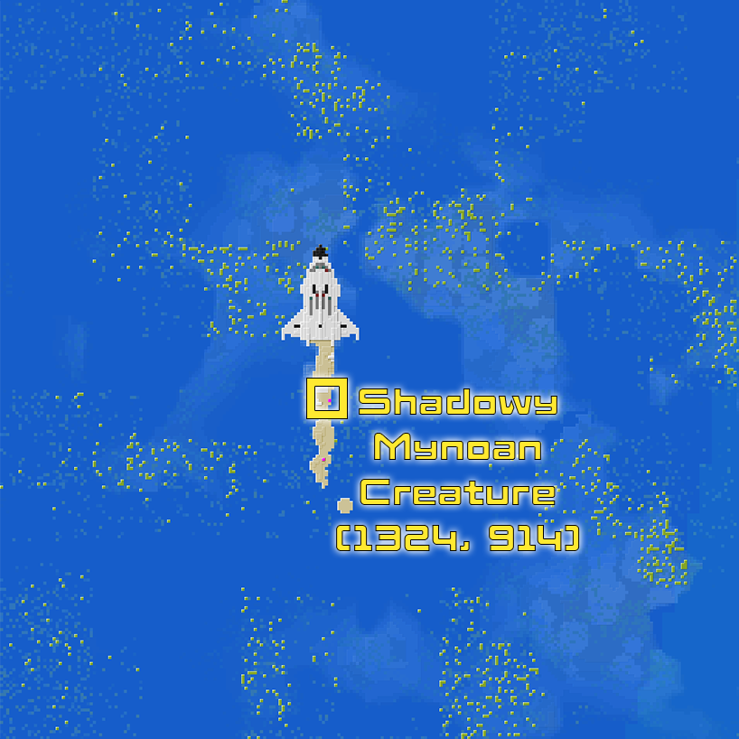
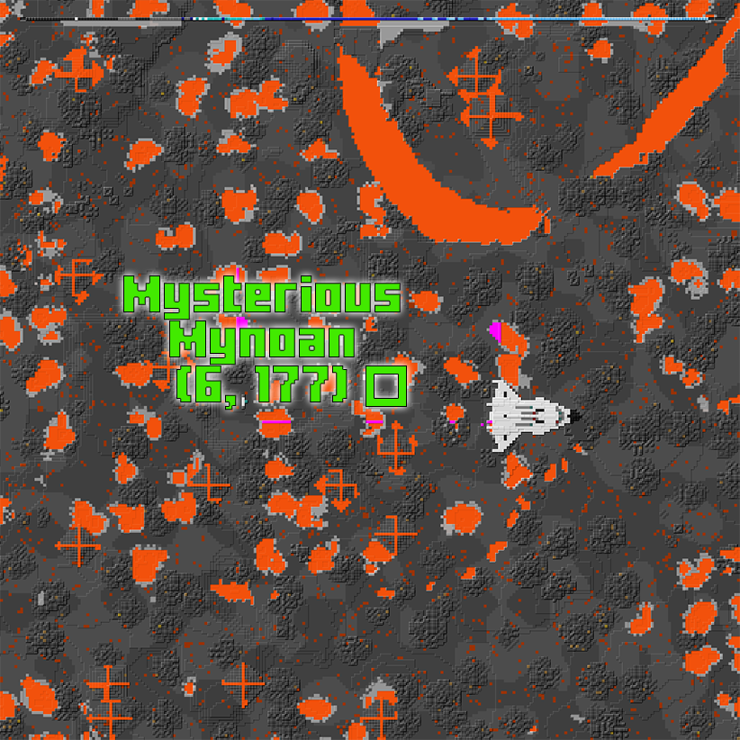

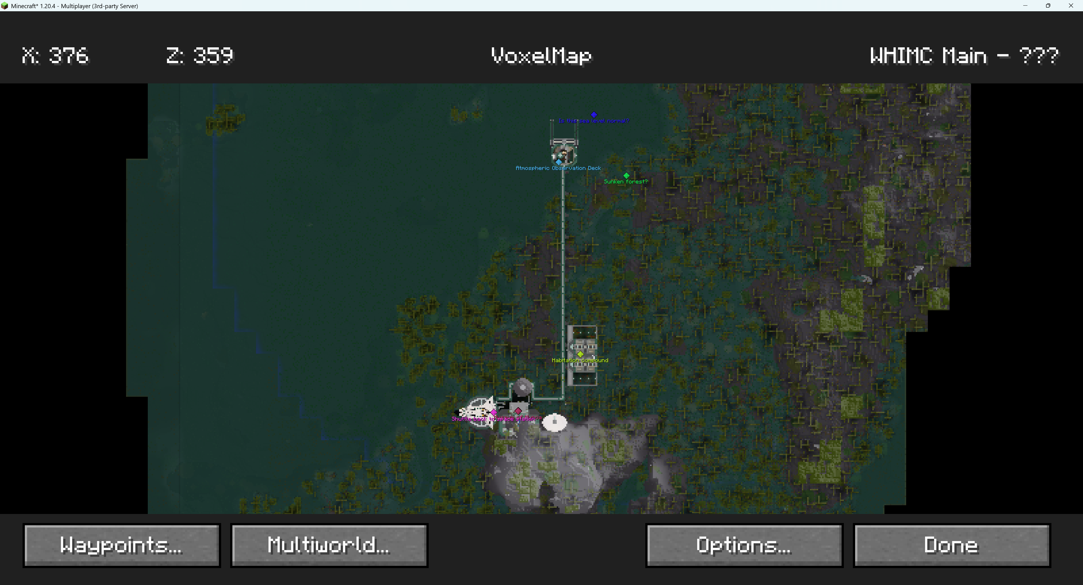
Notable features to observe include the variable-height loading dock, sunken forest, limp wind sock by the habitation compound, museum and exhibits – marked on the above map.

👩🏽‍🔬 NPC's and Their Roles
A non-player character (NPC) is a video game character that is controlled by the game's artificial intelligence (AI) rather than by a player. The NPC’s below are those that are tied to quests on the server or that offer relevant STEM information – there are others who may be present but not mentioned in this guide.
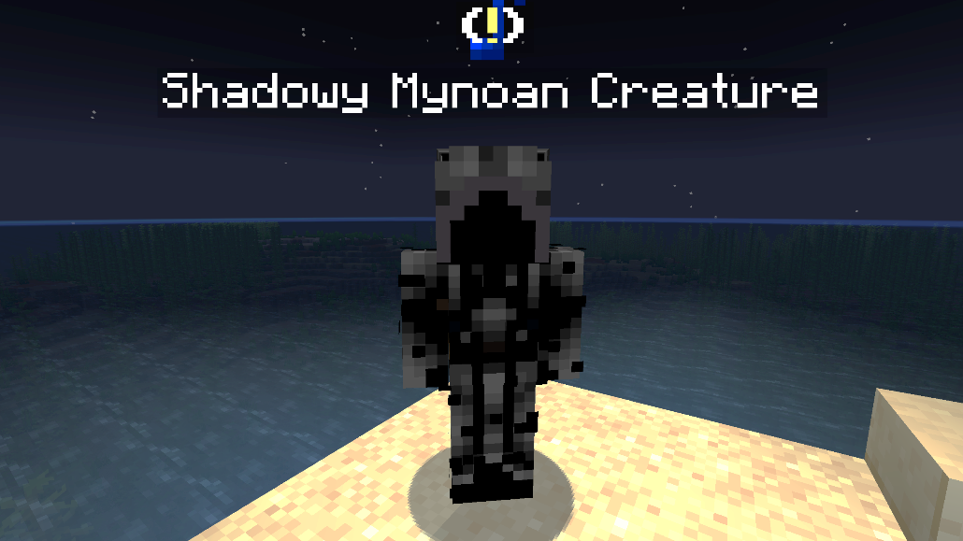 | Located at  x: 1323  y: 64  z: 914  ID: 204 | Shadowy Mynoan Creature (Mynoa Close) – Located nearby where the player spawns, gives side-quest Solis Defuit (this is Latin for “missing sun”) quest. Then asks students to infer why it is so dark in the area, asks them to measure the temperature, and then students make another inference on why the temperature is so low in the area and finally rewards them with a “Mynoan Lantern” custom item when finished.
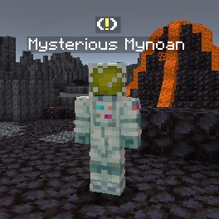 | Located at  x: 6  y: 92  z: 178  ID: 203 | Mysterious Mynoan (Mynoa Half)– The only character on the map, gives side-quest Wanna Knowa Mynoa? Asks students to measure the temperature in this new region, tell him using /observe why it is so hot, and measure the magnetic field of the planet to make an observation for why it is so strong. Rewards players with a “Mynoan Gold” custom item upon completion.
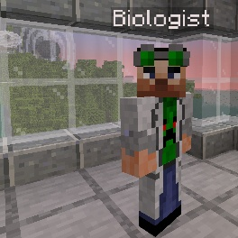 | Located at  x: 303  y: 83  z: 194  ID: 635 | Spectral Analyst (Mynoa Mangrove) – Standing on the atmospheric observation deck this NPC gives players the Mynoa Museum Mania! Quest and indicates they can pay attention to the auroras and gravity.
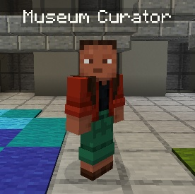 | Located at  x: 274  y: 76  z: 387  ID: 636 | Museum Curator (Mynoa Mangrove) – Found just inside the doors of the museum this NPC suggest players figure out what’s going on by exploring around.

